**CTA module:**

Following fields should be present in this module

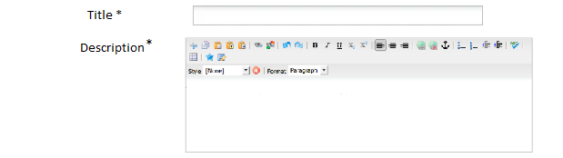



* Image should have the decorative text checkbox and the alt text field (standard process)
* Drop down fields for background color and Font color should be added as Mandatory fields
* Common “Button” module can be used in this module for the CTA buttons below the description

**News Feed:**

This module should have the following fields



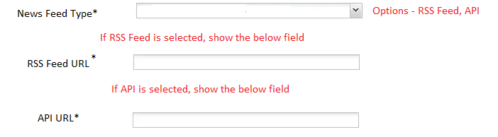

* Common “Button” module can be used in this module for the CTA button
* Add a Color selection field for the horizontal line below the tile
* There are 2 additional options for News feed in Crownpeak but they are not used anywhere. So we don’t have to build that in AEM
  + “Manual” – The news article title and date are entered manually and linked to the article
  + “Import” – In this case, news articles are created within site folder and the articles are automatically read from the selected folders.

**Ribbon Module:**

This module should have the below fields

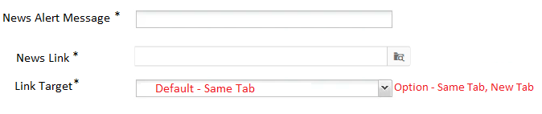

* Drop down fields for background color and Font color should be added as Mandatory fields

**Intro Text:**

* A simple RFT field alone is sufficient for this. So this module can be named as “RTF” rather than Intro text.
* Also, I see the font size of this text in PDP template to be 20px whereas the rest of the page content is 16px.
  + For flexibility, we can add another field for Font size with drop down values of – Small (16 px) / Medium (20 px) / Large (24 px) with Medium being defaulted so we can use this in another places as needed.

**Multi Column Control & Text Widget:**



* As per the current AEM implementation, the first step would be to determine the # of Tiles that needs to be added (attaching the screen shot from AEM)
  + I don’t understand the significance of the below checkbox. It can be removed if not needed
  + Also, the drop down for tablet is not needed. Max # of tiles is 4 per row and 4 tiles can be shown in tablet as well. So no explicit selection is needed as tab can follow desktop
  + The “Padding” label is not needed as there are no fields below that

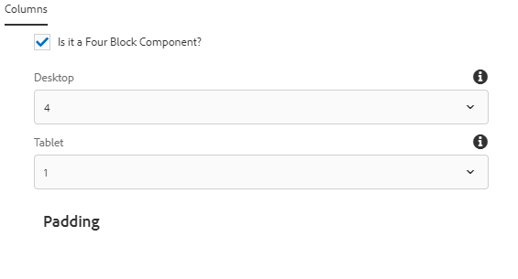

* Every tile should have the following fields

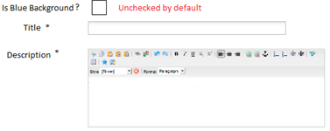

* + Blue background checkbox is needed because, this is optional today and any tile can have the blue background
  + If Blue background is unchecked, ONLY then show a field to select the color for the horizontal line above the tile.
  + Common “Button” module can be used in this module for the CTA buttons below the description